I downloaded ns3 from https://www.nsnam.org/releases/ns-3-45/
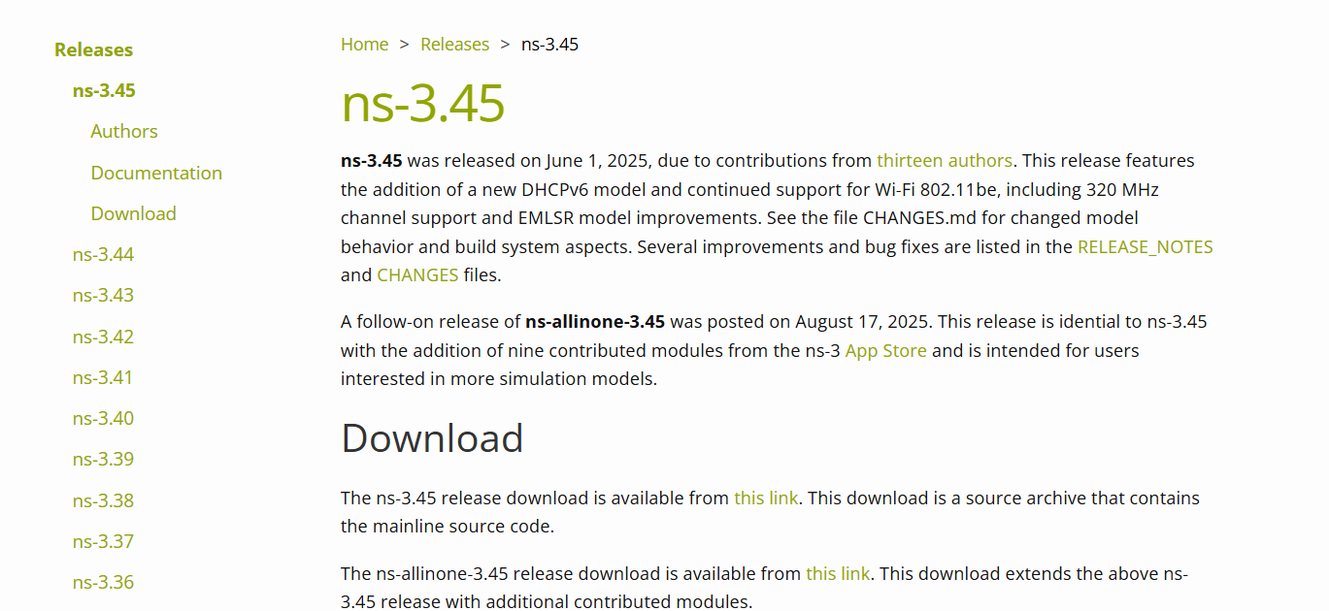
I updated the linux by sudo apt update
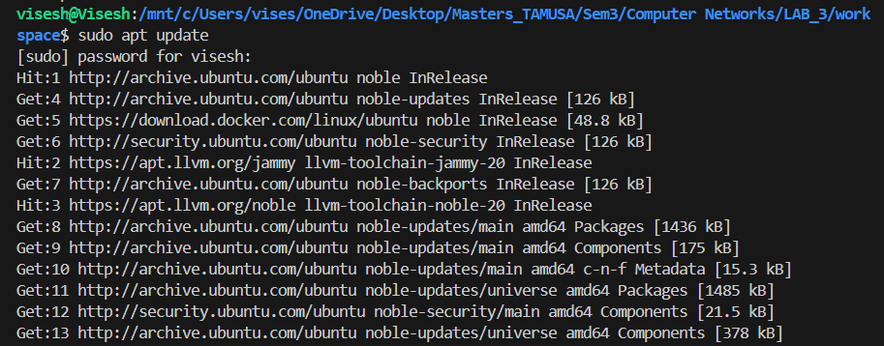
Sudo apt -y upgrade
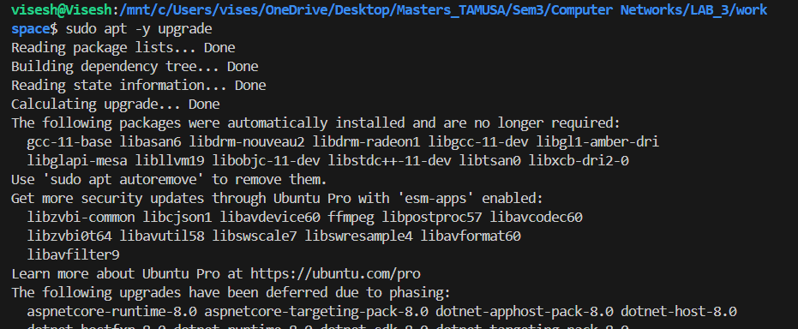
Install dependencies for NS-3 Python bindings
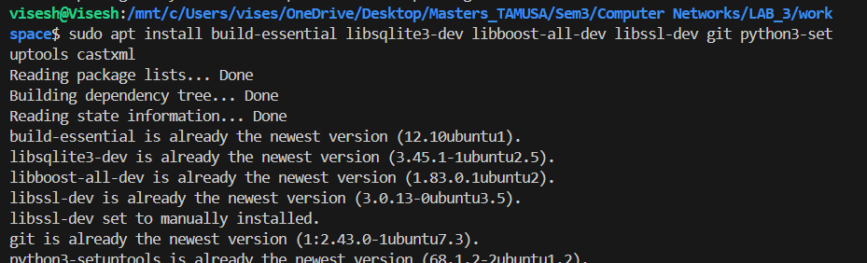
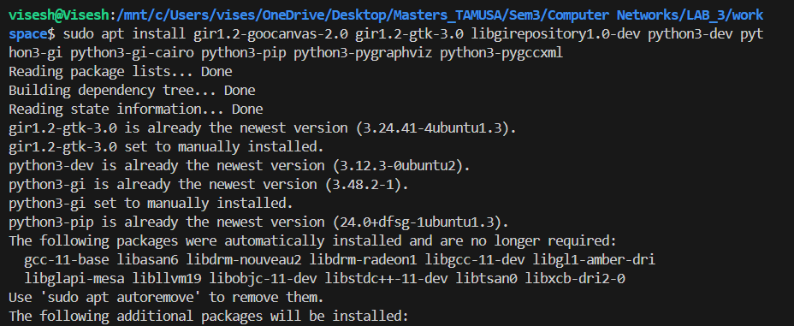
Then we check if all the files are there by using ls
Then we make file by cmake .. -DNS_EXAMPLES=ON -DNS3_TESTS=ON
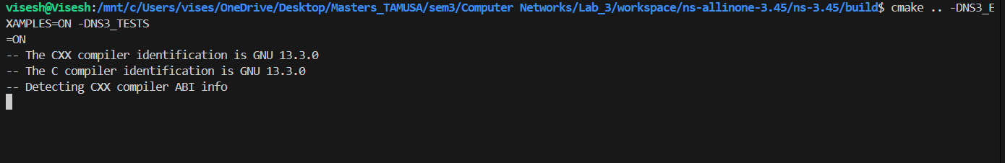
Then we can check what all are built
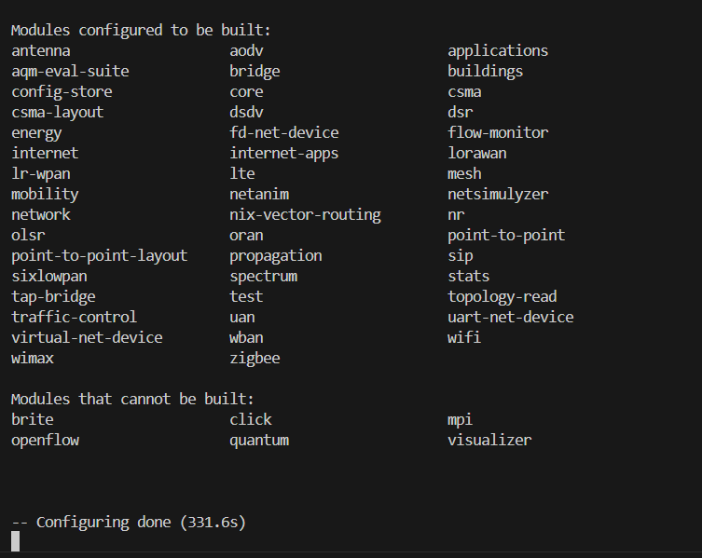

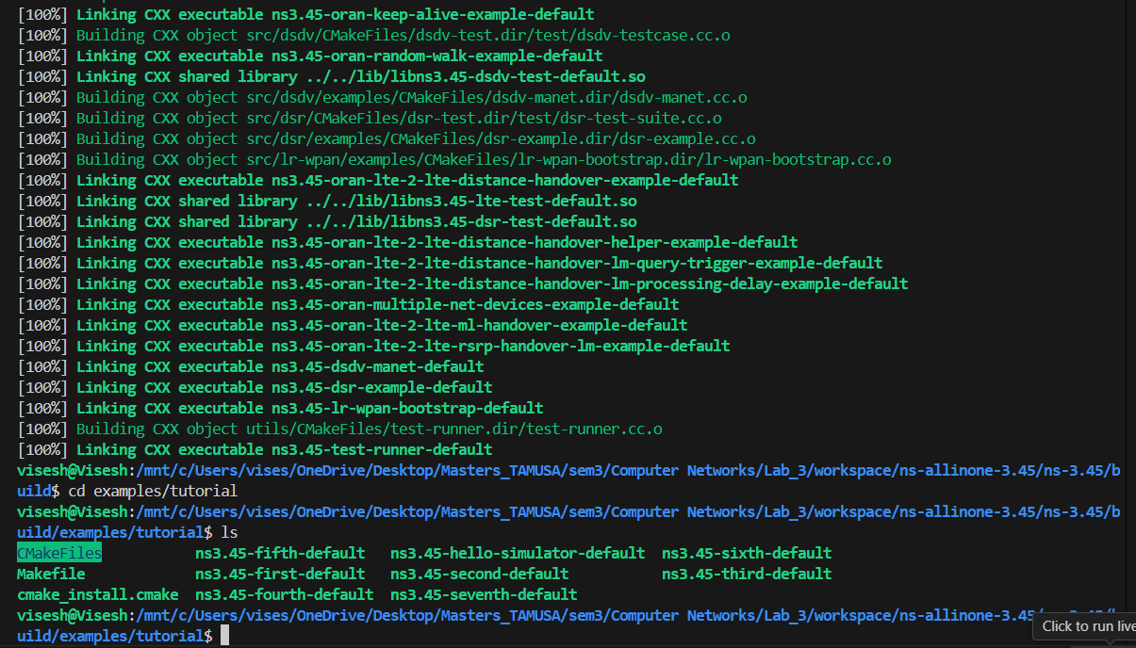
After successfully building we run the hello_simulator to check if ns3 installe perfectly.
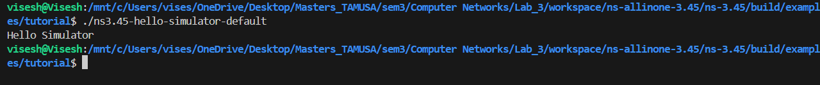
After that we run first and second
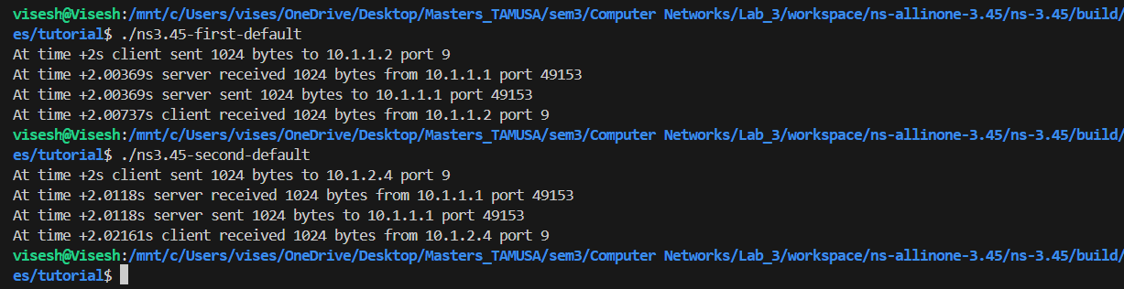
And other examples
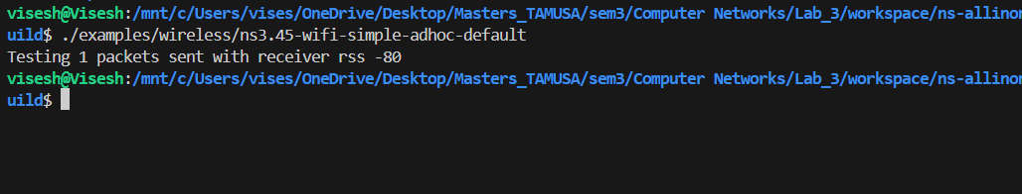
After that we install netanim
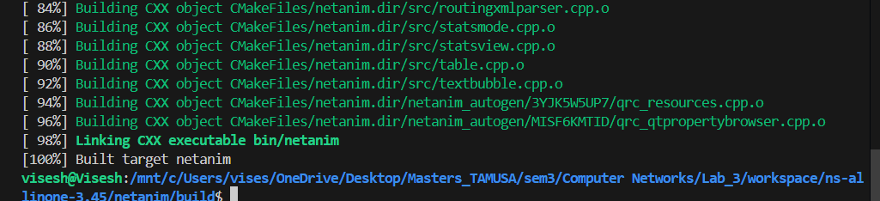
And check for it’s files
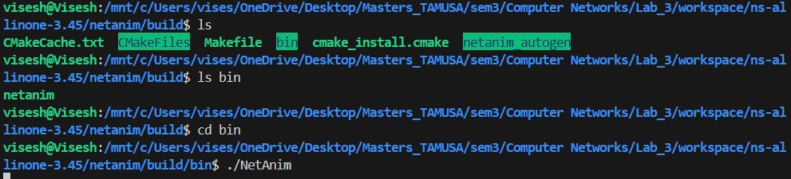
Then we make changes to first.cc file
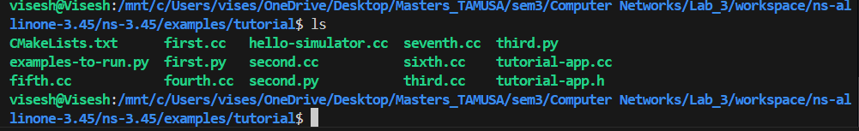
By clicking on nano first.cc we can make changes to it, we add netanim module and it’s binaries and add a small piece code at the end of the file
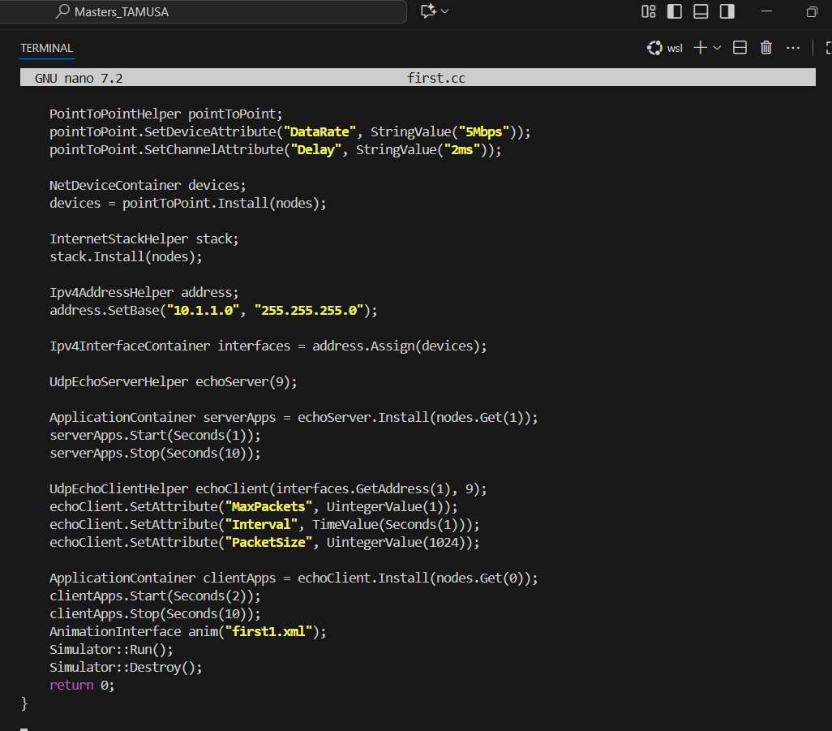
We also have to make changes to CMakeLists.txt file add ${libnetanim} to first.cc build example block
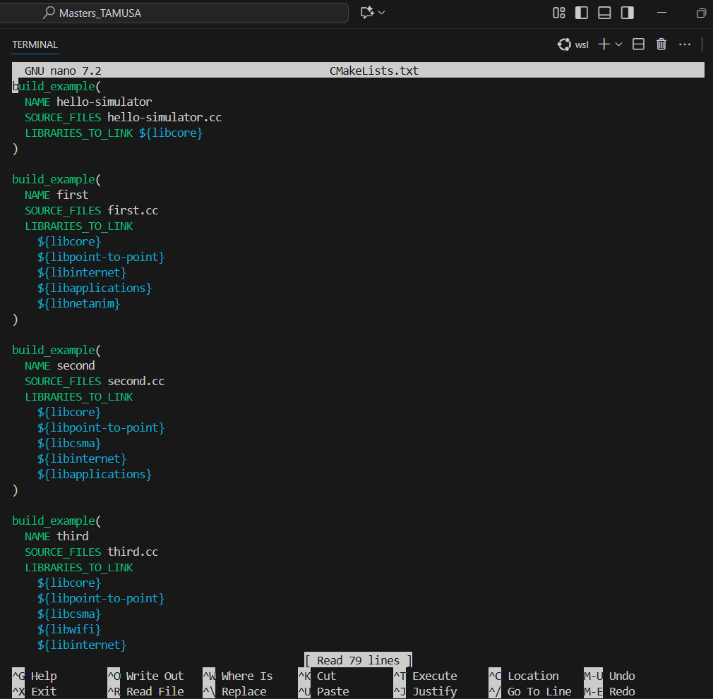
And then we run
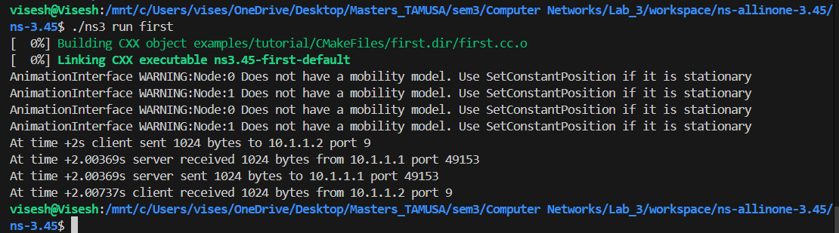
We can see a gui window opening up

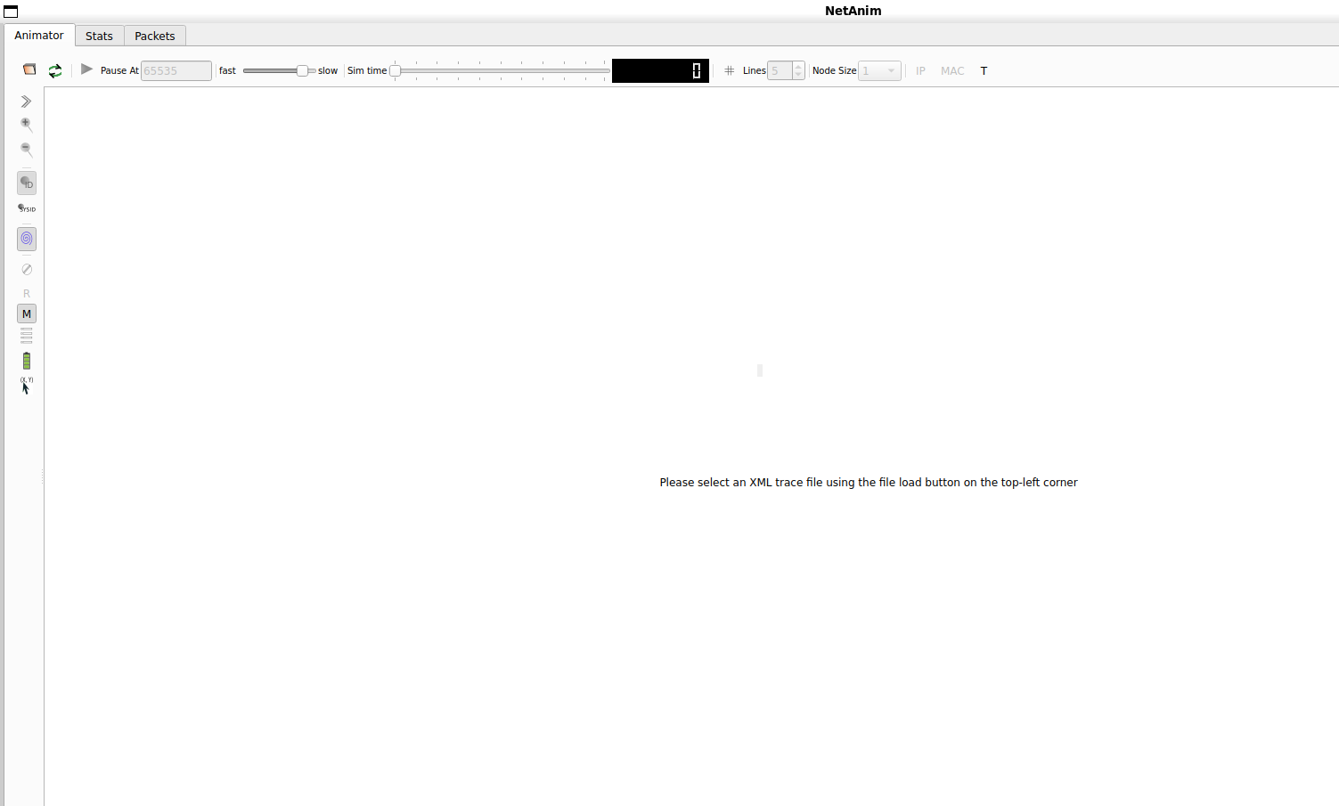

And then we choose first.xml file generated before and run it. U can see graphs below.
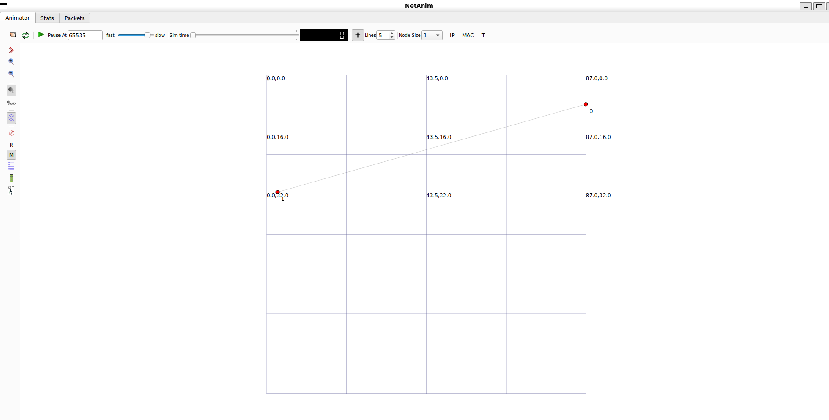
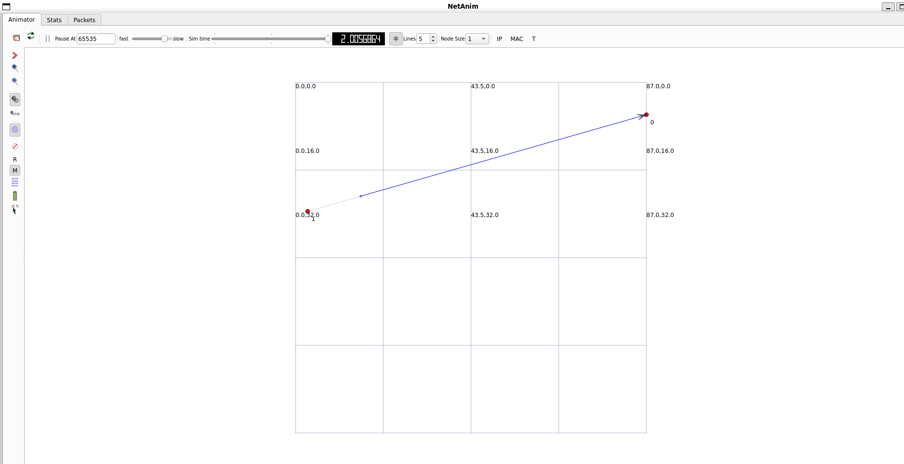

Summary:
In this lab, I downloaded and set up ns-3.45 on Linux, installed all the required dependencies, and successfully built the simulator. To confirm the installation, I ran built-in examples such as hello-simulator, first, and second.
Next, I installed NetAnim to visualize network simulations. I explored its files, edited the first.cc example to include the NetAnim module, and modified the build configuration so it would compile with the animation support. After recompiling, I generated an XML trace file (first.xml), opened it in NetAnim, and observed the GUI visualization with graphs that represent the simulation results.
FeedBack:
I was able to follow a step-by-step approach to install and test ns-3 and then extend it by integrating NetAnim for visualization. This process helped me practice my problem-solving skills, especially when making edits to source files and updating the build configurations.
One thing I could improve on is documenting the specific challenges I faced during the setup, such as missing files, build errors, or CMake issues, and how I resolved them. That would make my report more complete and also highlight my troubleshooting process. I also realize I could have added a short explanation of what the graphs in netanim represent, which would give more meaning to the results

